Claybrook Zoo – Map and Key 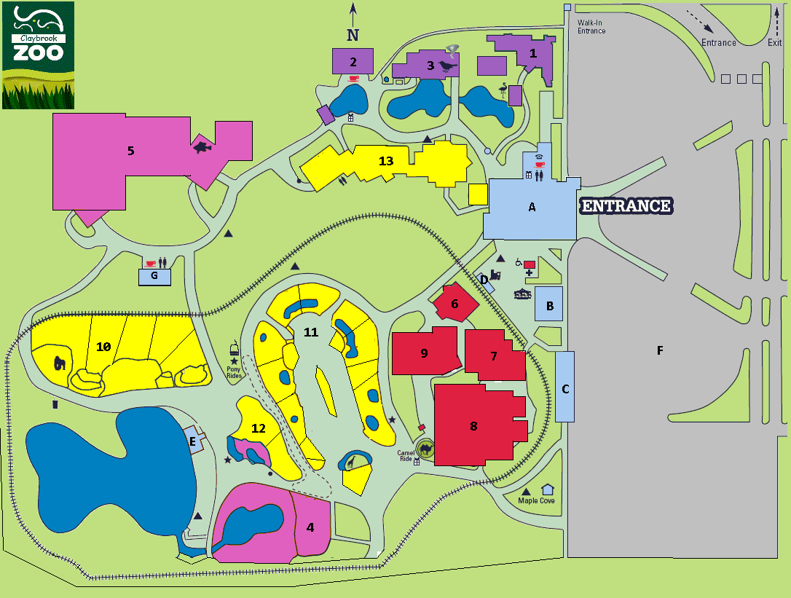
Claybrook Zoo – Map Key

Key | Type of Area/Building | Description
A | Administration | Visitors Centre
B | Administration | Managers Office
C | Administration | Administration and File Storage
D | Administration | Zoo Train (Ticket Sales)
E | Administration | Boat House (Ticket Sales)
F | Administration | Car Park
G | Administration | Cafe Block
1 | Aviary | Indoor and Outdoor Aviary Block 1
2 | Aviary | Indoor Aviary Block 2
3 | Aviary | Indoor Aviary Block 3
4 | Aquarium | Outdoor Aquarium Block 1
5 | Aquarium | Indoor Aquarium Block 2
6 | Hothouse | Amphibian/Reptile Block 1
7 | Hothouse | Amphibian/Reptile Block 2
8 | Hothouse | Amphibian/Reptile Block 3
9 | Hothouse | Amphibian/Reptile Block 4
10 | Mammal Compound/Cage | Mammal Outdoor Compound 1
11 | Mammal Compound/Cage | Mammal Outdoor Compound 2
12 | Mammal Compound/Cage | Mammal Outdoor Compound 3
13 | Mammal Compound/Cage | Mammal Indoor Caged Area 4

